Project Design Document
As of 7th April 2026
Dancing Doll Arcade – Aryan Puri, Arshia Khaund, Varanasi Manasa

1. Design Intent
What experience are you trying to create?
A rhythmic game which adapts the player to move their character along with the beats being presented on the screen. A fast-paced dancing rhythm game to keep the player on their toes to keep up with the beat and hit the keys at the right time. sense of competitiveness
Who is it for?
A younger audience with a good sense of rhythm.
If solving a problem, what problem does it solve?
It does not solve a problem, it cures boredom and provides a sense of competitiveness

2. Inspiration & References
Existing products / ideas
Arcade dance machines
Piano tiles
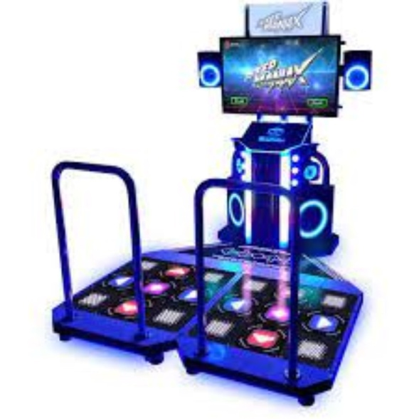

What did you learn from them?
Their ability to create a sense of time-based urgency to hit the notes at the right time and converts an audio to an enjoyable touch-based game and the arcade machine creates a 3d experience for the player to engage into the dancing element themselves.

3. User Journey
Step-by-step experience of the user:
- User presses start on their controller and the music starts, the character being controlled starts their idle resting motion, indicating its ready to dance. The notes start sliding into the OLED screen
- The user presses the buttons on the controller as the music instructions reach the end of the screen and the doll moves according to the button they press
- System responds by continuing the game unless the wrong button is pressed, the neo pixel blinks red and the music dies down, game over as the doll turns motionless and stops spinning

Success Criteria
- Making the doll dance as per the signs indicated on screen.
- Perfect movement of limbs joined by servo motors.
- Achieving the required master circuit for the entire game.
- Servo motor movement of doll makes it look like dancing and not mechanical moves.
- Make the hat spinning
- Correct led indication and working of the spotlight

System Overview
This project is an interactive animatronic control system where a user operates a console to trigger and observe physical movements performed by a character. The console, built using an ESP32, displays randomized directional prompts such as up, down, left, right, and jump, along with simple on-screen animations that demonstrate the exact movement the animatronic is about to perform.
The user responds through button inputs, and these inputs are processed and sent to a second ESP32 that controls the animatronic. Based on the received commands, the character executes corresponding movements using servo motors for its limbs, while a stepper motor independently drives a continuous hat rotation as a visual element. The system also includes a start sound and background music that plays independently of the movement, along with a stop function to control playback.
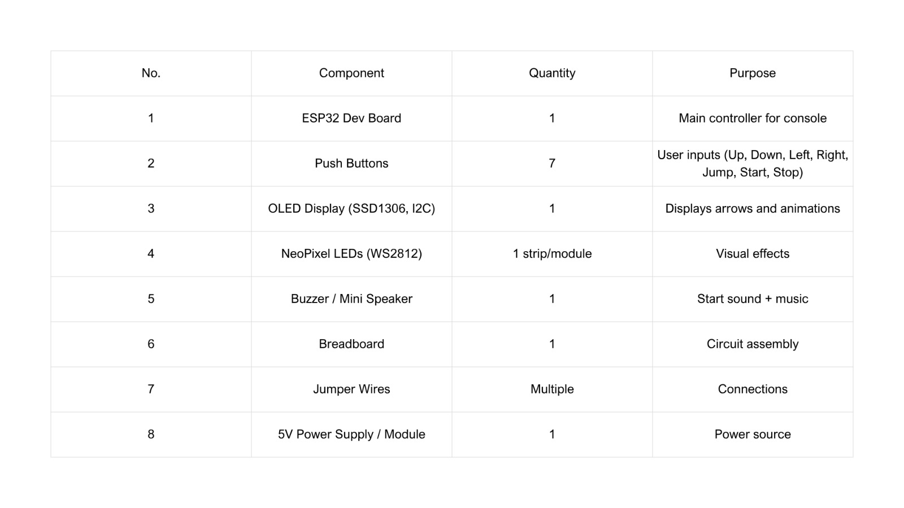

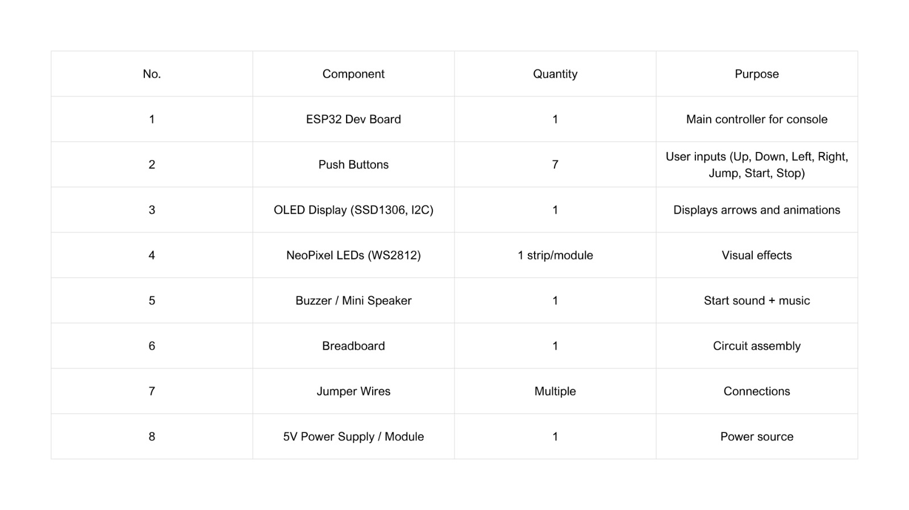

6. High-Level Block Diagram
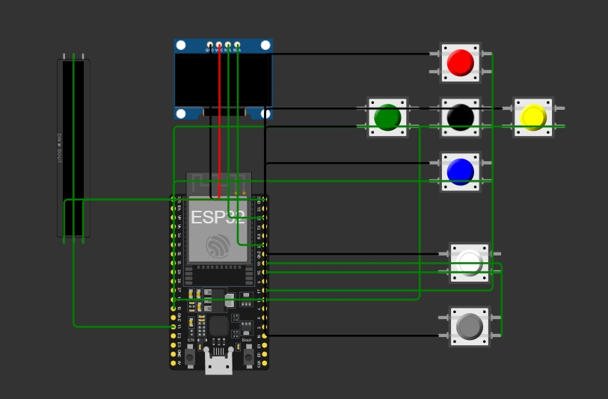

7. Input / Output Mapping
Input | Process | Output
Push buttons  (console)  OLED screen | The required keys to be pressed on the screen for the players | MOTORS:  The puppet moving its limbs  light acting as a spotlight on the stage

8. Sketches & Concepts
